POCKETSMART AI
Project Team

TEAM LEADER
ROHITH S
NM ID: 4B2937F3713DEDE9E6A4941AEABE84A1
TEAM MEMBER
CHANDRU T
NM ID: 907B183358FBBB99AF14E7F18D917DC9
TEAM MEMBER
HEEDHESH R
NM ID: 40D4B6DFD412A2597FC4FADD8710CC96
TEAM MEMBER
ASHWIN S
NM ID: 446946BAC63A2BEA45F45AA4CA3D3B47

POCKETSMART AI
AI-Powered Smart Planning & Recommendation Web Application
PROJECT DOCUMENTATION
Prepared from the submitted PocketSmart AI project source code
September 2026

1. Abstract
PocketSmart AI is a web-based smart planning application designed to help users generate practical recommendations for different personal planning scenarios. The project provides a browser-based interface with user authentication, planning modules, recommendation generation, and history management. The application is implemented as a Python web application and uses an AI integration where configured to produce more personalized recommendations.
The system is organized around separate planning experiences such as Home, Party, and Jewelry planning. Users can enter relevant preferences and receive recommendations through the application interface. The project also maintains user-related state and history so that previous planning activity can be accessed again.

2. Introduction
Planning purchases, events, and lifestyle requirements can involve comparing many options while staying within a budget or preference set. PocketSmart AI attempts to simplify this process by collecting user requirements through focused forms and converting them into useful recommendations.
The project combines a conventional web stack with Python server-side processing and optional generative-AI functionality. This makes it suitable as an academic full-stack/AI project demonstrating frontend design, backend routing, authentication, data handling, and API integration.

3. Problem Statement
Users often need help selecting suitable products, arrangements, or ideas according to requirements such as category, occasion, preferences, and budget. Manual research can be time-consuming and may produce scattered results. A centralized recommendation system can collect these requirements and return structured suggestions through a single interface.

4. Objectives
- Provide a simple web interface for smart planning
- Collect user requirements through dedicated planning forms
- Generate recommendations based on the submitted inputs
- Support authenticated user sessions
- Preserve useful planning history
- Integrate generative AI when the configured AI service is available
- Demonstrate practical full-stack application development

5. Key Features
- User registration/login and logout flow
- Home planning module
- Party planning module
- Jewelry planning module
- Recommendation generation
- History access for previous planning activity
- Session-based user state
- Responsive web interface using HTML/CSS/JavaScript
- Python/Flask backend routing and processing
- AI integration support

6. Technology Stack
Backend | Python with Flask (detected in source code)
Frontend | HTML, CSS and JavaScript
AI | Google Gemini / generative AI integration is present in the project source
Data/State | SQLite/data persistence references are present
Authentication | Login/logout and session-related functionality are present

7. System Architecture
The application follows a client-server architecture. The browser provides the presentation layer. User requests are sent to the Python backend, where routes process input, apply application logic, interact with storage/services, and return HTML or generated results. Where configured, an AI service is called to create recommendation content.
Flow: User → Web Interface → Flask Routes → Application Logic → Storage / AI Service → Recommendation Result → User Interface

8. Module Description

8.1 Authentication Module
Handles user access through registration/login-related functionality and maintains session information during use. Logout ends the authenticated session.

8.2 Home Planner
Provides a planning interface for home-related requirements. User inputs are collected and processed to produce suitable recommendations.

8.3 Party Planner
Helps users plan party-related requirements by collecting event preferences and generating recommendations based on the submitted details.

8.4 Jewelry Planner
Provides a dedicated planning flow for jewelry-related requirements, allowing recommendations to be generated from user-selected criteria.

8.5 AI Recommendation Module
The AI layer converts structured user requirements into recommendation content. When an AI provider/API key is configured, the backend can send an appropriate prompt and process the generated response.

8.6 History Module
Stores or displays previous planning activity so users can revisit earlier recommendations and inputs.

9. Typical Workflow
- User opens PocketSmart AI
- User creates an account or logs in
- User selects the required planner
- User enters preferences and requirements
- Backend validates and processes the input
- Recommendation logic/AI generates the result
- Result is displayed in the browser
- Relevant activity can be stored in history
- User can return later and review previous planning activity

10. Project Structure
The submitted project contains Python backend code together with frontend templates/assets. The exact file names may vary with the submitted ZIP structure.
pocketsmart/.env.example
pocketsmart/.gitignore
pocketsmart/README.md
pocketsmart/app.py
pocketsmart/models/__init__.py
pocketsmart/requirements.txt
pocketsmart/services/__init__.py
pocketsmart/services/ai_engine.py
pocketsmart/services/mock_ai.py
pocketsmart/static/style.css
pocketsmart/templates/base.html
pocketsmart/templates/dashboard.html
pocketsmart/templates/history.html
pocketsmart/templates/index.html
pocketsmart/templates/login.html
pocketsmart/templates/planner_home.html
pocketsmart/templates/planner_jewelry.html
pocketsmart/templates/planner_party.html
pocketsmart/templates/register.html
pocketsmart/templates/results_home.html
pocketsmart/templates/results_jewelry.html
pocketsmart/templates/results_party.html

11. Installation and Setup
Recommended setup for local development:
- Install Python 3.x
- Extract the PocketSmart AI project
- Open a terminal in the project directory
- Create and activate a virtual environment:
python -m venv venv
venv\Scripts\activate (Windows)
source venv/bin/activate (Linux/macOS)

- Install dependencies from the project's requirements file, if included:
pip install -r requirements.txt

- Configure required environment variables/API keys according to the project's configuration
- Start the Flask application using its configured entry point
- Open the local URL shown by Flask in a web browser

12. Configuration & Security
- API keys and secret credentials should be kept outside publicly shared source code
- Environment variables or a local .env configuration should be used where supported
- Debug mode should be disabled in production
- Passwords should be stored using secure hashing rather than plain text
- Input validation should be applied to user-provided values

13. Testing
Suggested functional tests include: registration with valid and invalid data; login/logout; opening each planner; submitting valid planner inputs; handling missing inputs; generating recommendations with and without AI configuration; saving and viewing history; refreshing authenticated pages; and checking unauthorized access to protected routes.
Expected result: valid inputs should produce the intended planning/recommendation response, while invalid or incomplete inputs should be handled gracefully without exposing application errors or credentials.

14. Advantages
- Centralized planning experience
- User-focused recommendation workflow
- Modular planner design
- AI can make recommendations more personalized
- Demonstrates frontend and backend integration
- Can be extended with additional planning categories and services

15. Limitations
- AI recommendations depend on the configured AI service and its availability
- Generated recommendations should be treated as suggestions rather than guaranteed or professional advice
- Production deployment requires stronger security, validation, monitoring, and scalable data storage
- Recommendation quality depends on the quality and completeness of user inputs

16. Future Enhancements
- Add more planning categories
- Add richer user profiles and preference learning
- Add budget tracking and cost comparison
- Add recommendation feedback and rating mechanisms for system improvement
- Add image-based recommendations where appropriate
- Add downloadable/shareable plans
- Deploy using a production WSGI server and managed database
- Add automated tests and CI/CD

17. Conclusion
PocketSmart AI demonstrates how a Python web application can combine structured user input, modular planning features, authentication, history, and generative AI to create a practical recommendation platform. The project provides a strong foundation for further development into a more comprehensive personalized planning system.

18. Viva / Interview Questions
- Why did you choose Flask for the backend?
- How does the login/session mechanism work?
- How are planner inputs sent from frontend to backend?
- How is AI integrated into the application?
- How do you protect API keys?
- How is recommendation history stored?
- What happens when the AI API is unavailable?
- How would you deploy this project?
- What security improvements are needed for production?
- How could the recommendation system be improved in future?

Appendix A. Application Screenshots
The following screenshots demonstrate the working application: the development environment, account creation, the dashboard, and the Home Planner producing an AI-generated budget plan.

A.1 Development Environment
The project's source structure, styling variables, and the build assistant's setup summary inside the IDE.
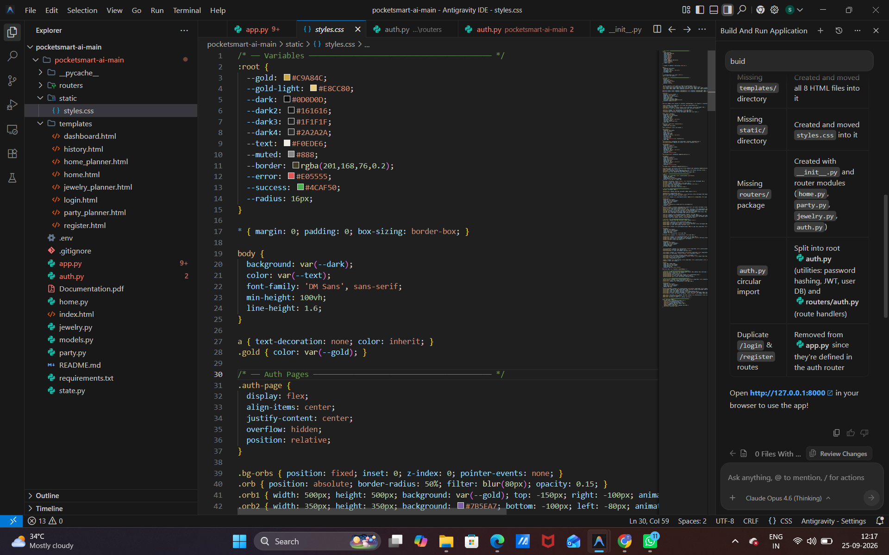
Fig. A.1 — Project source tree and styles.css in the Antigravity IDE

A.2 Account Creation
The registration screen where a new user creates a PocketSmart AI account.
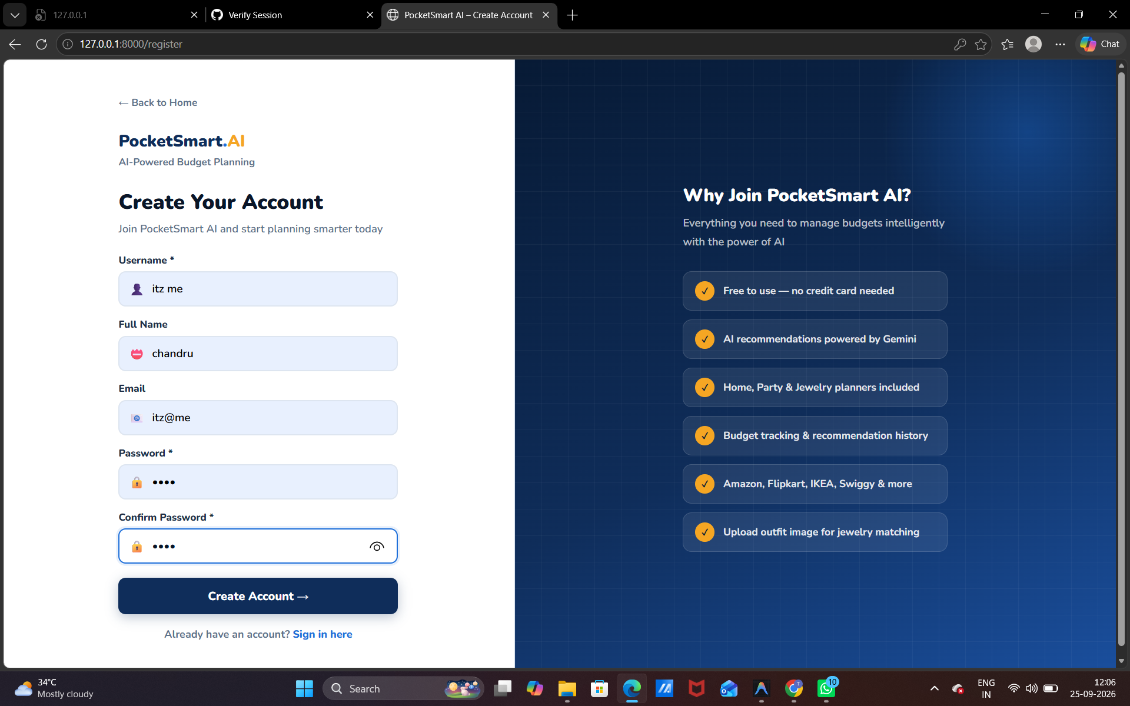
Fig. A.2 — Create Account page

A.3 Dashboard
The main dashboard after login, showing recommendation stats and the three smart budget planners.
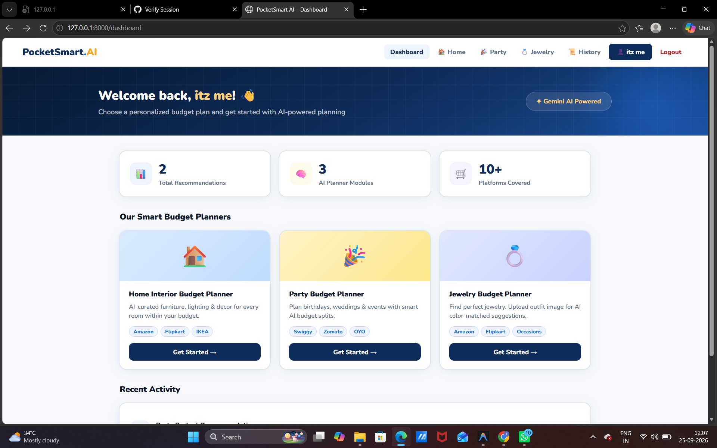
Fig. A.3 — Dashboard with Home, Party and Jewelry planner cards

A.4 Home Planner — Requirements Form
The Home Interior Budget Planner form, where the user enters budget, rooms, style and preferred shopping platforms.
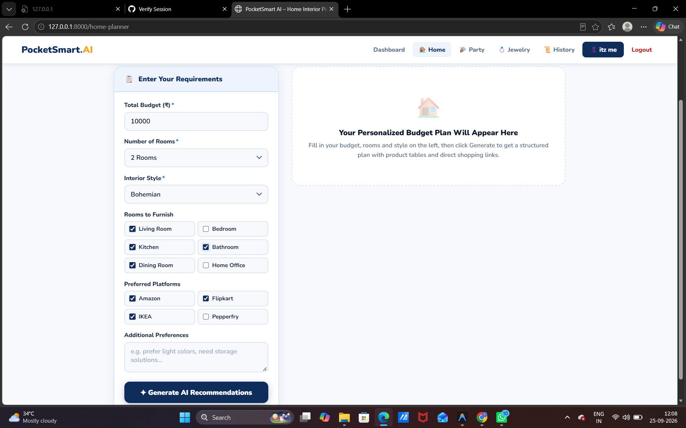
Fig. A.4 — Home planner input form, before generating recommendations

A.5 Home Planner — AI-Generated Plan
The resulting AI-generated budget plan, with a budget summary and itemized, categorized product recommendations with shopping links.
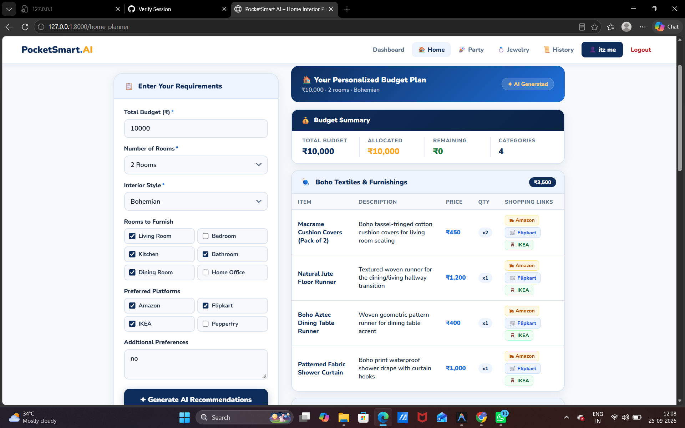
Fig. A.5 — Generated budget plan with itemized shopping recommendations

